**Developers Guide:**

**Vingers Food Restaurant**

| **Supervisor.** | **Sir Ebad Uddin** | |
| --- | --- | --- |
| **Batch.** | **2210C2** | |
| **Group.** | A | |
| **Serial No.** | **Enrollment Number** | **Student Name** |
| 1. | 1424655 | Abdur Raffay Sheikh |
| 2. | 1424363 | Sadia Bader |
| 3. | 1423495 | Wajiha Khadim Hussain |

# 1.Home (Index.html):

**Banner:**

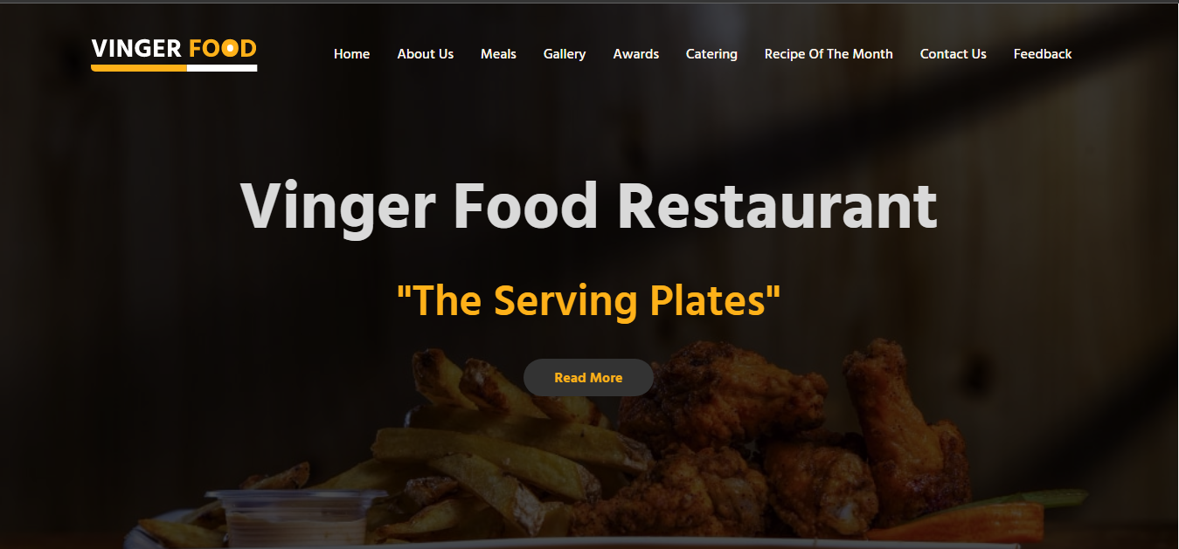

**Specifications:**

* Has Multiple different sections
* The Hero section is displayed prominently at the top with a changing background image.
* Animated Design
* 5 Other Sections Excluding Header and Footer
* Fully Responsive design for both mobiles and Tablet Devices

**Other Sections of Home:**

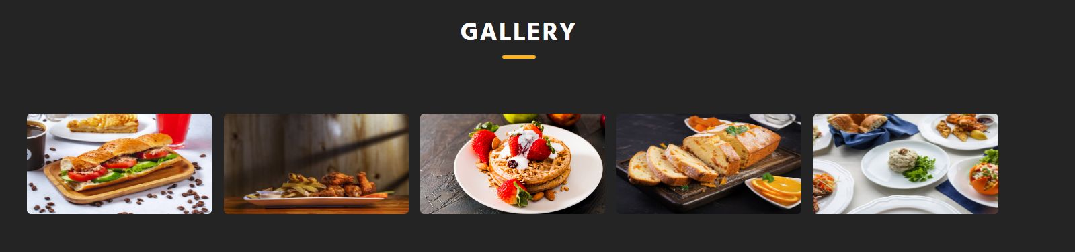

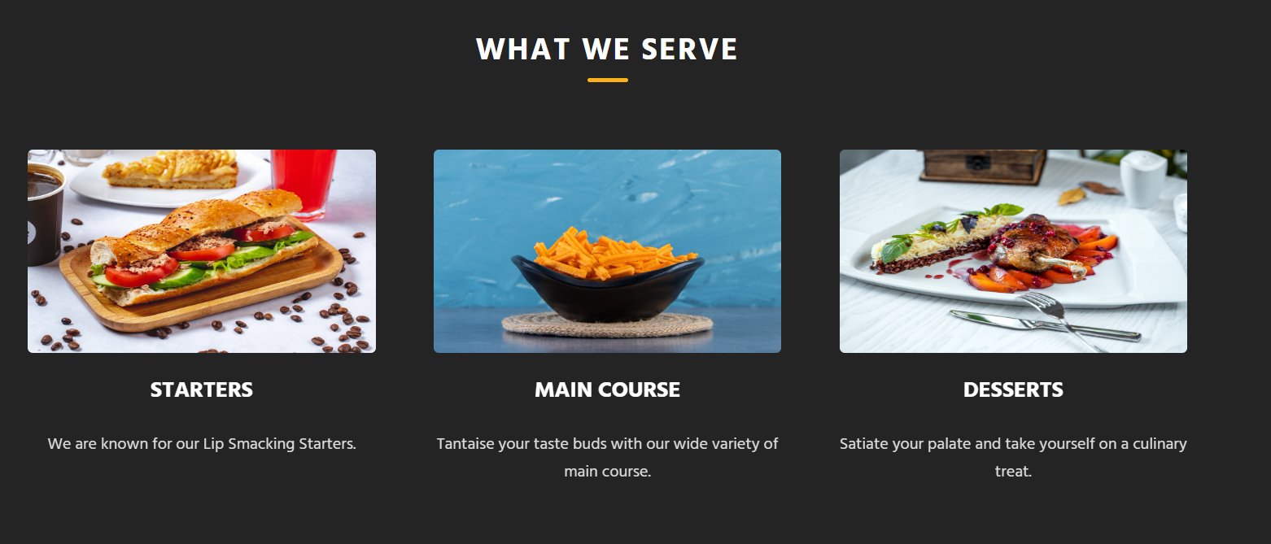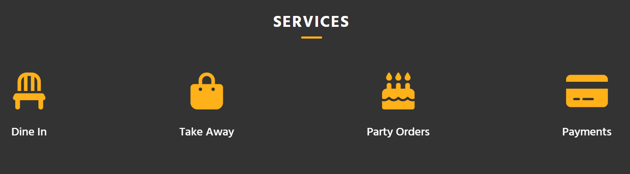

**Code Of Home:**

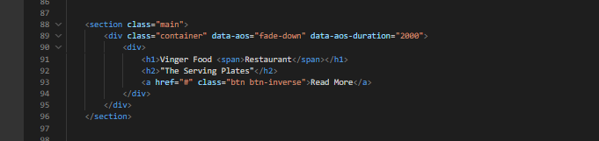

# 2.Navbar:

# 

**Specifications:**

* Responsive Design
* Includes Logo and Navigation Links
* Fulfills All Requirements
* Clear and concise and Easy Navigation
* Uses Custom Hamburger Menu
* Minimalistic Design uncluttered layout that allows users to easily navigate the menu and find what they are looking for

**Code Of Navbar:**

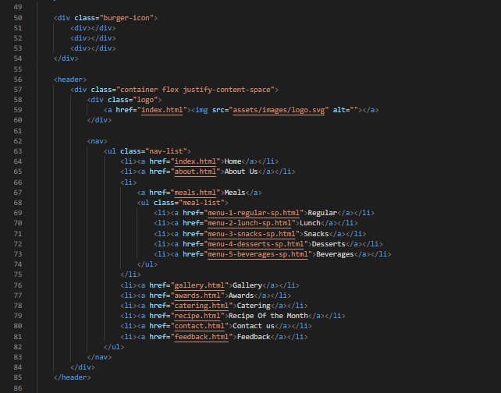

# 3.About us(about.html):

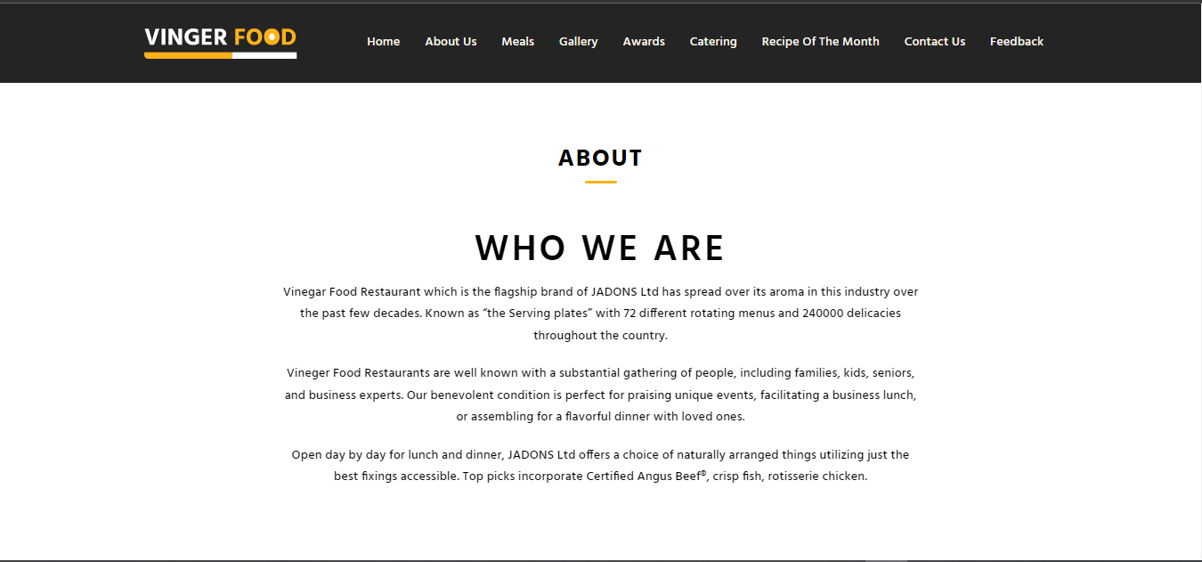

**Specifications:**

* Fully Responsive
* Provides users information about our restaurant
* Minimalist Design

**Code Of About Us:**

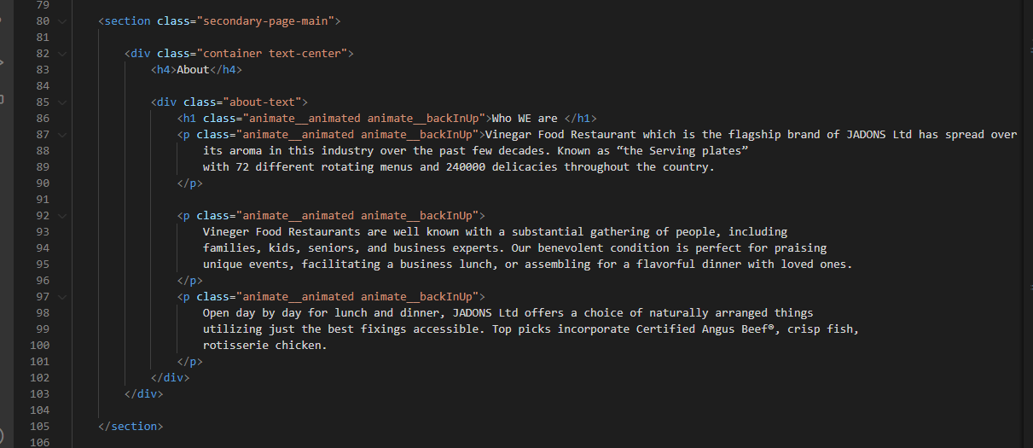

# 4.Meals/Meals Subpages (meals.html):

**Main:**

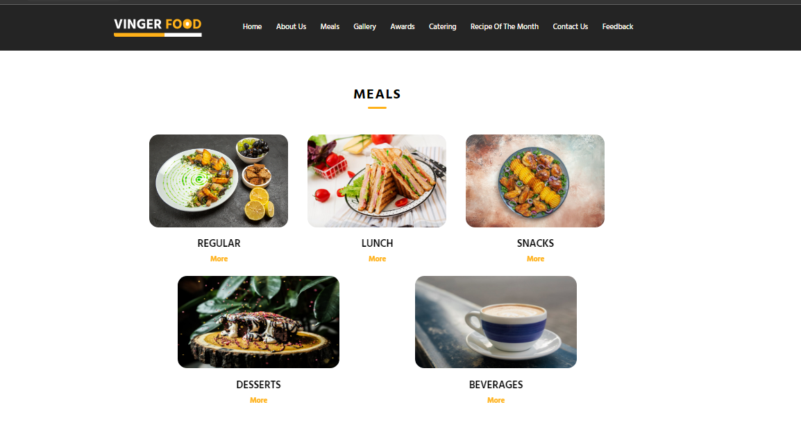

**Subpage:**

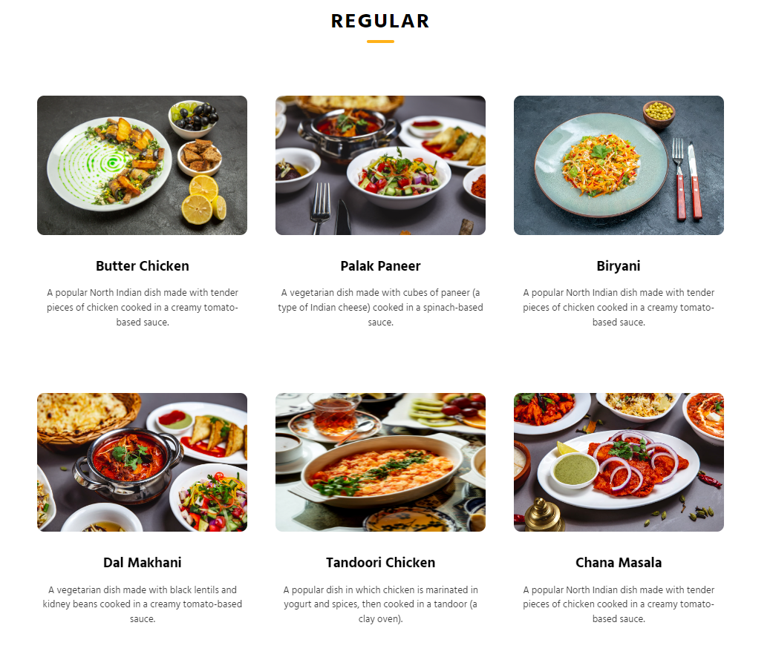

**Specifications:**

* Fully Responsive Design
* This page shows users different ranges of food Available.
* All the categories are mentioned as per design
* Multi Navigation- User Can use both this page and Navigation bar to reach the desired sub page
* The pages include: Regular, Lunch, Snacks, Desserts and Beverages subpages.

**Code of Meals:**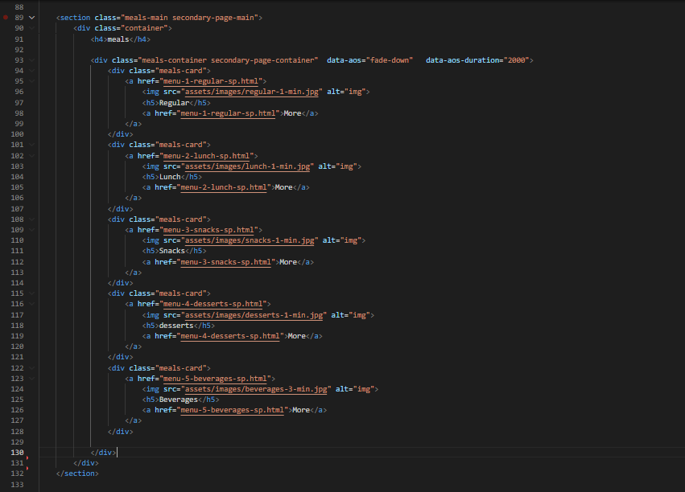

**Code of Meals Subpage:**

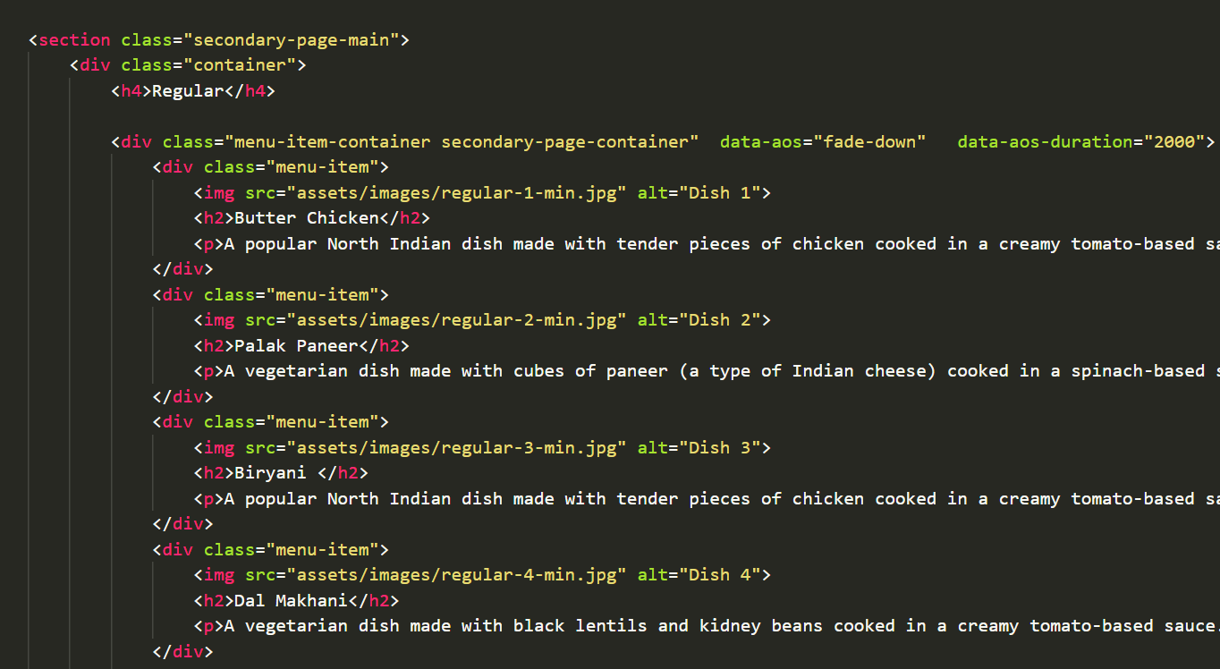

# 5.Gallery/Awards/Catering/Recipe:

**Specifications:**

* **Fully Responsive Design**
* **These pages are used to give users insight of the restaurant's food.**
* **All of the pages are responsive.**
* **They use different animations to make the website look more attractive**

**Gallery:**

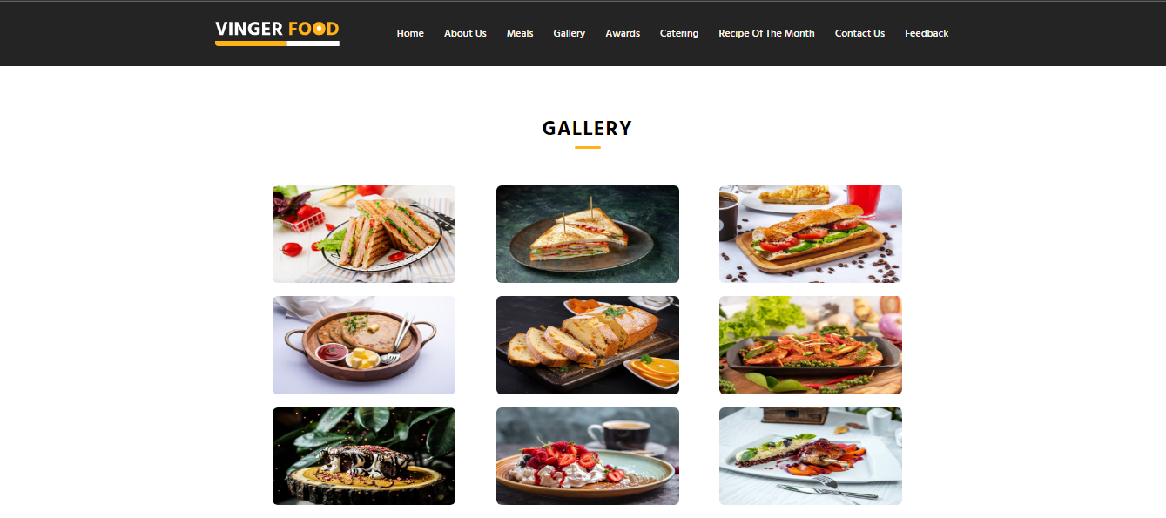

**Gallery Code:**

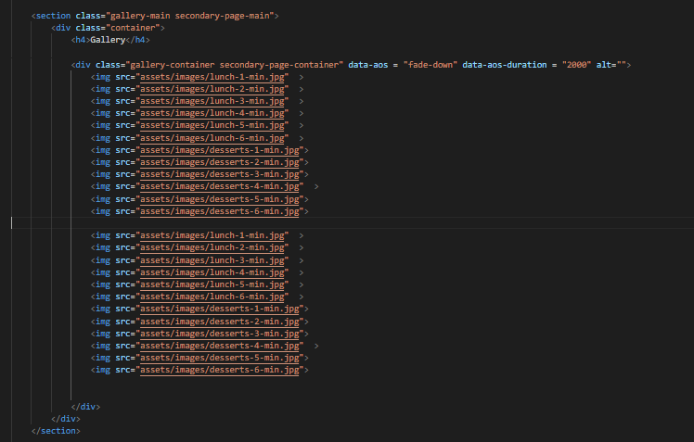

**Awards:**

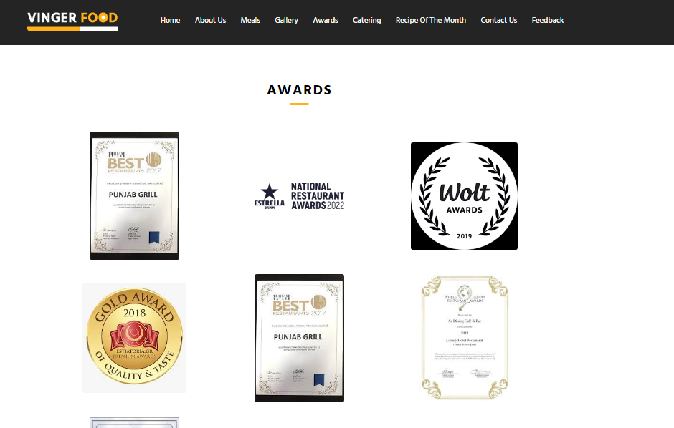

**Awards Code:**

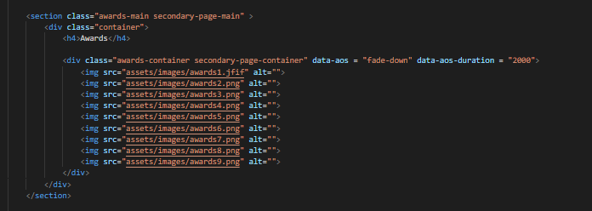

**Catering:**

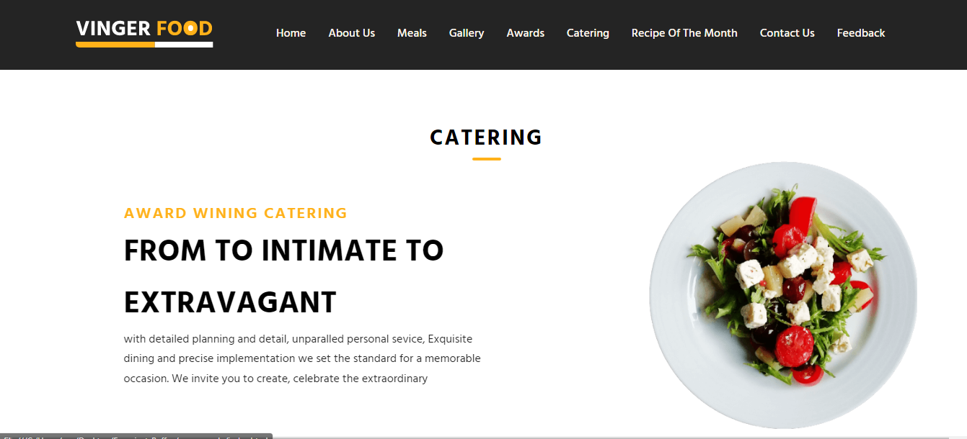

**Catering Code:**

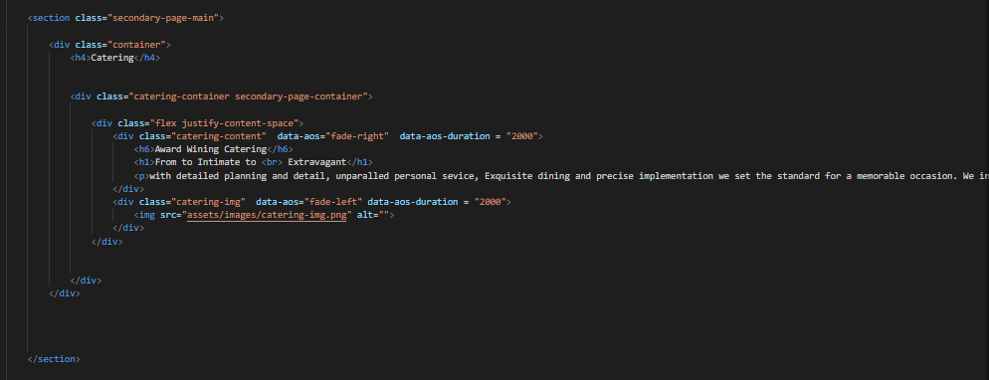

**Recipe of the Month:**

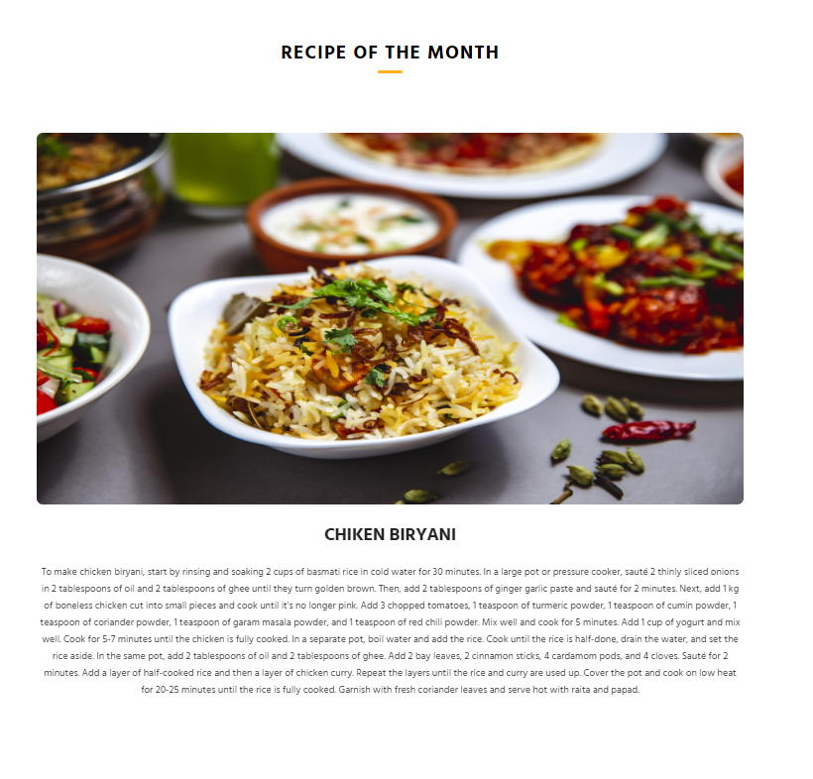

**Recipe of the Month code:**

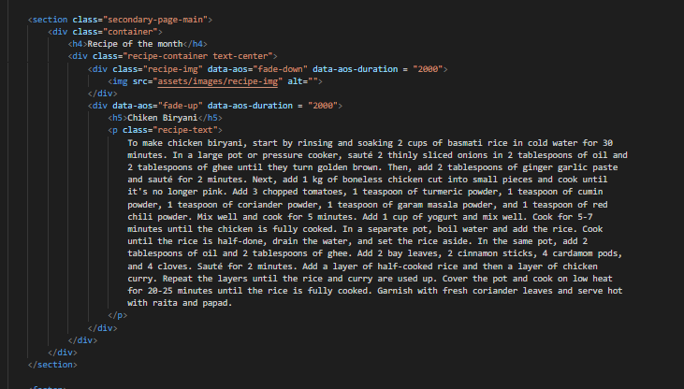

# 6.ContactUs/Sitemap/Feedback:

**Specifications:**

* **Fully Responsive Design**
* **Firstly, The contact us page can be used by the user to send queries and make reservations. The same page has a different section of sitemap.**
* **Feedback: Users can use this page to provide feedback using multiple options given to them.**

**Contact Us/Sitemap:**

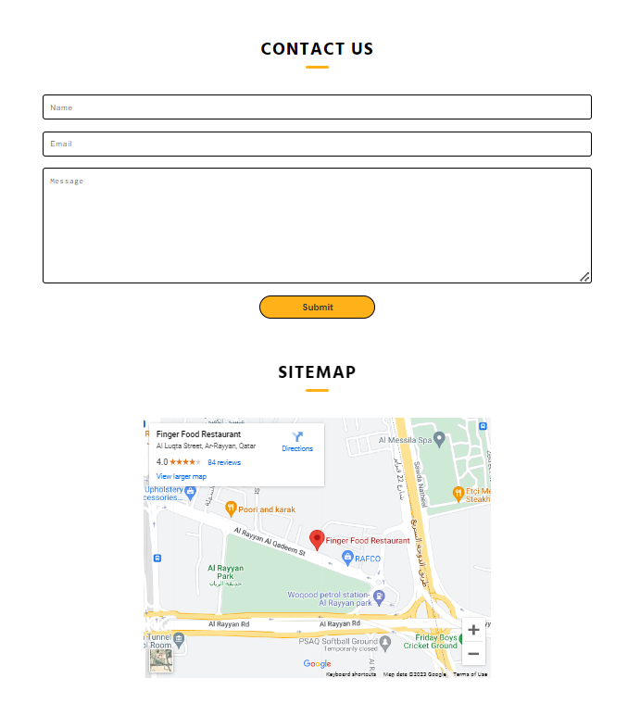

**Contact Us/Sitemap Code:**

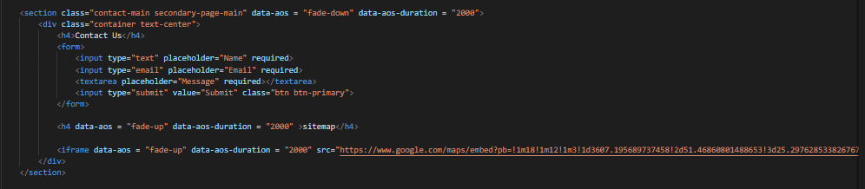

**Feedback:**

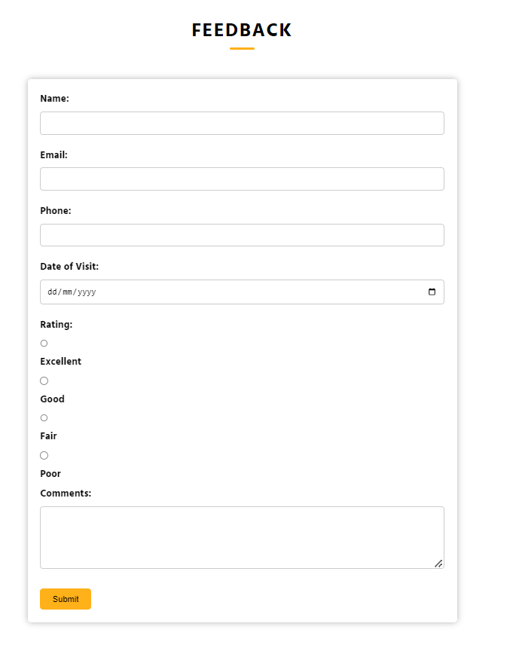

**Feedback Code:**

